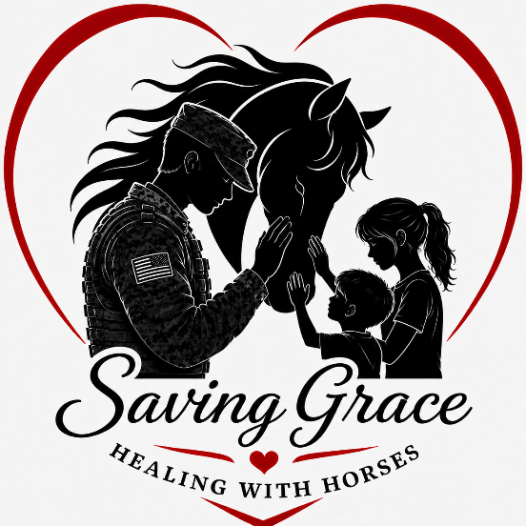

Volunteer Information and Release Form
To Be Determined and approved: Our mission is to foster personal achievement by providing therapeutic experiences using horse related activities for persons with disabilities or other special challenges.

GENERAL INFORMATION
Name: _______________________________________(Preferred Name)______________________
Address: ___________________________________________________________________________
School/Employer: ____________________________________DOB: ________T-Shirt Size:_______
Can we text you? O Yes O NO
Email:___________________________________________ Contact ph#_______________________
How did you hear about us?: O Family O Friends o School O Online O DriveBy o Other
If Other, Please Specify: _____________________________________________________________
Are you a current Armed Service member or Veteran? O Yes ONO
LESSON VOLUNTEERS
Do you have any physical limitations? O Yes O NO
If Yes, Please Specify:
Can you walk for 60minutes? O Yes ONO Can you jog short distances? O Yes O NO
Do you have any experience with horses/ponies? O Yes O NO
If Yes, Please Specify:__________________________________________________________________________
Do you have any experience with individuals with special needs or other skills/training which may be of benefit? (Certifications, Sign Language, CPR, RN, etc.) List:___________________________________________
________________________________________________________________________________________________________________________________________________________________________________________
OTHER VOLUNTEER OPPORTUNITIES
Saving Grace Healing with Horses needs help in various ways in addition to working directly in lessons Please check your area(s) of interest.
Facility/Office: __ Office/Telephone O Hay __Facility Maintenance __Sessions __ Barn Chores
Committees: __Small Event Assistant ___Fundraisers __Horse Care __Public Relations
Other Volunteer Opportunity Ideas: ____________________________________________________________________________________________
Please note all available days/times:_________________________________________________________________________________
____________________________________________________________________________________________

BACKGROUND INFORMATION
Saving Grace reserves the right to perform background checks and/or drug screenings on all volunteers.
Current Driver's License? O Yes O NO License Number: _______________________State:________
IN CASE OF AN EMERGENCY NOTIFICATIONS
Primary Name: __________________________________Relationship:__________ Phone:___________
Secondary Name: _______________________________Relationship:___________Phone:___________
Allergies/medical concerns: ___________________________________________________________________________________________

PUBLICITY RELEASE
0 I consent 0 I do not consent
to and authorize the use and reproduction by Saving Grace Healing with Horses of any and all photographs and any other audio-visual materials taken of me for promotional material, educational activities, and exhibitions or for any other use for the benefit of the program.
CONFIDENTIALITY STATEMENT
The volunteer shall keep confidential all medical, social, referral, personal and financial information regarding a rider, their family, other volunteers or staff, including information on Saving Grace Healing with Horses' mailing lists. Additionally, there will be no posting of pictures or other information on any social networking site, i.e. Facebook, Twitter, YouTube, etc. without expressed permission of Saving Grace and the parents or guardians of the participant.
________(initials) I understand and will observe the confidentiality policy of Saving Grace Healing with Horses
RELEASE AND INDEMNITY AGREEMENT
By signing below, I affirmatively state that as a volunteer of Saving Grace Healing with Horses, I understand and agree to release, discharge, and hold harmless all instructors, therapists, staff, horse owners, or any and all other parties, agents, or representatives involved with Saving Grace from liability for all manner of claims, demands, and damages I may have, whether for property damage or personal injury, resulting from or in any way growing out of my participation as a volunteer for Saving Grace.
Under Tennessee law, an equine professional is not liable for an injury to or death of a participant in equine activities resulting from the inherent risks of equine activities, pursuant to Tennessee Code Annotated, Title 44, Chapter 20, Section 1.
The signature below attests that I/we have read and understand each of the above-mentioned releases in accordance with Saving Grace’s policy.
Volunteer Signature: __________________________________________________________Date:_________
Parent-Guardian (if under 18) : _________________________________________________Date:_________
Parent/Guardian Signature (if under 18) : ________________________________________Date:_________

Saving Grace Staff Use only:
FORM REVIEWED: Date: ________________ BY:_____________________________________________
VOLUNTEERS MUST INITIAL ONCE PER YEAR TO VERIFY INFORMATION IS CURRENT.
-ANY CHANGES MAY REQUIRE A NEW FORM-

