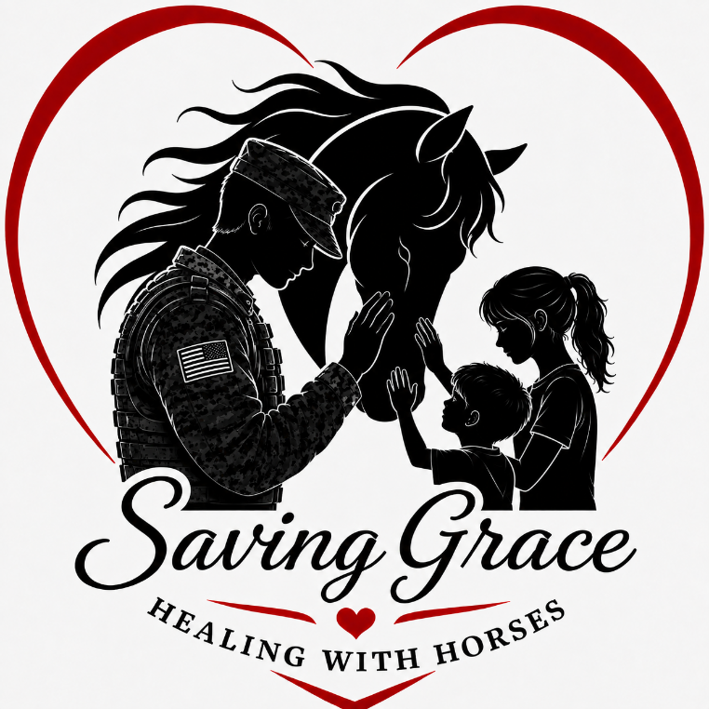
WAIVER OF LIABILITY, ASSUMPTION OF RISK AND INDEMNITY AGREEMENT
Horse riding is a dangerous activity and horses can act in a sudden and unpredictable manner, which may result in serious injury or death.

By signing this form, I acknowledge that I recognize the inherent risks involved in riding, working and being in close proximity of horses and their environment including but not limited to:
• Bites, kicks, abrasions or contusions from horses.
• Being thrown or bucked off by a horse. • Scratches or other injury from stalls or enclosures.
• Scratches or other injury from grooming tools and other equine equipment and tack.
• Allergic reactions to animal’s hay or other allergens.
• Tripping in holes or on materials or equipment.
• Slipping, falling or otherwise being injured in the arena, stalls or on the grounds, which may be slippery, muddy, wet, contain, or present other hazards.
IMPORTANT NOTICE
BY SIGNING THIS AGREEMENT, YOU ARE GIVNG UP CERTAIN LEGAL RIGHTS, INCLUDING THE RIGHT TO RECOVER DAMAGES IN CASE OF INJURY, DEATH OR PROPERTY DAMAGE, WHICH MAY OCCUR AS A RESULT OF HORSE RIDING OR PARTICIPATION IN EQUINE ACTIVITES AT Judy Ogden dba Saving Grace-Healing with Horses.
READ THIS DOCUMENT CAREFULLY BEFORE SIGNING IT. YOUR SIGNATURE INDICATES YOUR UNDERSTANDING OF AND AGREEMENT TO ITS TERMS.

________ (Initial) I hereby forever waive and release Judy Ogden dba Saving Grace-Healing with Horses and its principles and agents from any liability for injury arising out of the inherent risks from riding, working or participating in a stable environment and/or with horses.
_________ (Initial) By signing this agreement, I hereby acknowledge that although there maybe supervision on site Judy Ogden dba Saving Grace-Healing with Horses, its principles or agents bear no responsibility for my health or medical care.
_________ (Initial) I agree to indemnify, save and hold harmless Judy Ogden dba Saving Grace-Healing with Horses and its principles or agents from and against any loss, liability, damage, legal fees or costs that they may incur due to either my presence or participation at Judy Ogden dba Saving Grace-Healing with Horses.

Name of Rider_______________________________________________________________
Name of Guardian (if rider under18 years of age)________________________________________ Address____________________________________________________________________
Contact Phone nos.___________________________________________________________
EA/HRCAV/PCAV Membership nos.______________________________________________
Emergency Contact: Name_________________________Nos:______________________________
This agreement refers to you personally, any person in your care or minors under the age of 18 years and any other person in your group who may have accompanied you and is in the care of yourself or any other participant.

Date_____________ Signature of Rider/Guardian ________________________________________

